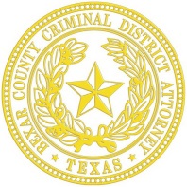
Nicholas “Nico” LaHood
Criminal District Attorney
Bexar County, Texas

PRESS RELEASE

FOR IMMEDIATE RELEASE

Bexar County Grand Jury Votes to Not Indict Former UIW Officer

San Antonio, Texas, March 24, 2015: Today, a Bexar County Grand Jury voted not to indict Christopher Carter, formerly of the University of Incarnate Word Police Department, for the shooting death of Robert Cameron Redus. As a result of this decision, no criminal charges will be filed by the Grand Jury.

This case has been investigated by the University of Incarnate Word, the Alamo Heights Police Department, the Texas Rangers, and the FBI. The District Attorney’s Office presented all evidence gathered during a thorough, independent investigation of the shooting.

NOTE:
*Because of long standing Texas law, the Texas Code of Criminal Procedure prohibits the disclosure of any events that transpired before the Grand Jury.
*Any requests to get copies of reports (including the audio recording) must be submitted through a Public of Information Act Request to the appropriate agency.

*The District Attorney’s Office is not involved in any civil lawsuits pertaining to this matter.

